DMDW LAB – 2

AIM: Demonstrate performing classification on data sets

THEORY:

Classification is a fundamental machine learning task where the goal is to assign predefined labels or categories to data points based on their features. It plays a crucial role in solving a wide range of practical problems by automating the categorization of data. Some of the problems that can be solved with classification include:

* Spam Email Detection: Classifying emails as either spam or non-spam.
* Disease Diagnosis: Diagnosing diseases based on patient symptoms and test results.
* Sentiment Analysis: Determining the sentiment of a piece of text (e.g., positive, negative, neutral).
* Image Classification: Identifying objects or objects in images.
* Credit Scoring: Assessing the creditworthiness of individuals.
* Fraud Detection: Identifying fraudulent transactions.
* Customer Churn Prediction: Predicting whether a customer will leave a service or stay.

In machine learning, there are several classification algorithms to choose from. Here are some commonly used ones:

* Logistic Regression:

It's a linear classification algorithm that's simple and interpretable.

* Decision Trees:

Decision trees use a tree-like structure to make decisions based on feature values.

* k-Nearest Neighbors (k-NN):

k-NN classifies data points based on the majority class among their k-nearest neighbors.

* Support Vector Machines (SVM):

SVM finds a hyperplane that best separates data into different classes.

* Naive Bayes:

It's a probabilistic classification algorithm based on Bayes' theorem.

* Random Forest:

Random Forest is an ensemble method that combines multiple decision trees for improved accuracy.

* Neural Networks:

Neural networks are complex models inspired by the human brain and are highly adaptable to various classification tasks.

OUTPUT:

Steps to perform Classification:

Step1: Create a csv file

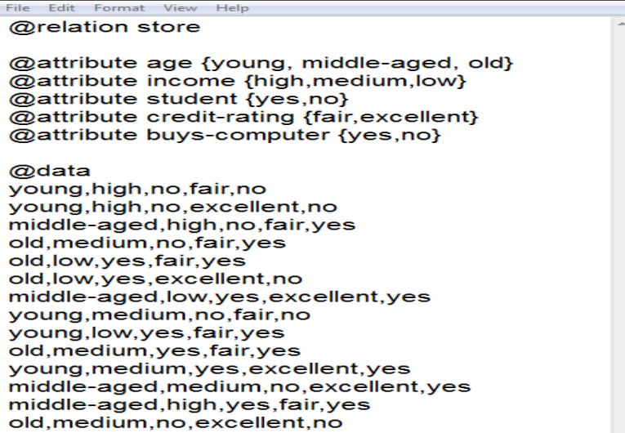

Step2: Open weka explorer and then select all the attributes in the table.

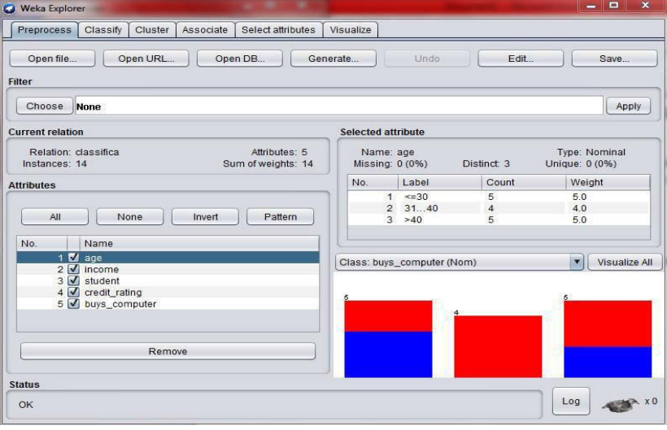

Step3: Open the classify tab on the WEKA explorer

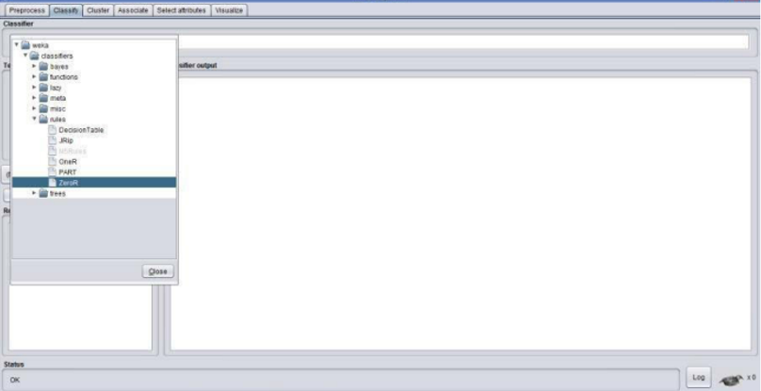

Step4: Select the classifier tab in the tool and choose the classification type (example: baye‟s folder and then naïve baye‟s classifier) to see the result.

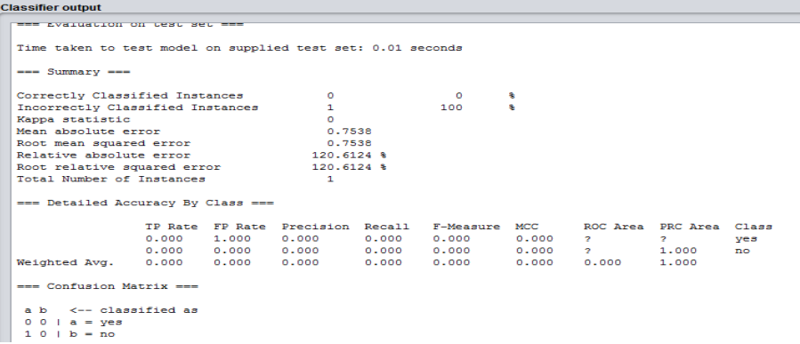

CONCLUSION:

Successfully implemented classification on a dataset using WEKA tool.